Storm and Climate Data Record (SCDR)
Implementation Plan

Date of record:
Calendar Year 2025

Principal Investigator: Karver Stockstill

I. Introduction

1.1 Overview and purpose
The purpose of this data analysis is to further assist the Miami Police Department (MPD) with determining property crime percentages related to storm events in the Miami area. This analysis will help the MPD determine and prepare resources more accurately for the property crimes that are likely be committed during the next storm event in Miami.

1.2 Define why you need data analysis
Data analysis will provide the MPD with accurate information regarding the relationships that occur between storm events and property crimes. By using data analytics, we are able to extract the precise data needed to create an understanding interpretation of how property crimes and storm events co-exist. By using analytics to create this report, the MPD will be able to more accurately prepare and allocate resource deployments in storm events based on severity of property crimes, showcasing an increase in response and reaction times to emergency calls.

II. Data Preparations

2.1 Name data sources
The data sources used for this analysis consist of Miami Police Department (MPD) calendar year of 2024 “mpdCrimeData2024” crime data alongside storm data from the same year “stormEvents2024. ” These two data sources will give us a detailed analysis of how crime and storm events align with one another. Since both of these dataset give us an entire year to work with we will be able to create an accurate interpretation for predicting and preparation of property crimes during storm events. We will also be using MySQL to help with formatting the data sets provided and then using Python language to create the analysis and visualizations.

2.2 Filter through unnecessary data
The datasets that we received to perform this analysis include information not pertinent to the conclusion we are looking for. For the MPD crime dataset we need to filter out only property crimes, since all other crimes are irrelevant for the analysis, focusing our attention on crimes consisting of; burglary, larceny-theft, motor-vehicle theft, and arson (FBI). The storm events data given is a national dataset, we need to filter out only the storm events that occur within the state of Florida and the city of Miami. By doing that we can have the appropriate data just for Miami to give us the correct analysis for the MPD.

2.3 Define your parameters
The parameters used for this analysis are property crimes committed during storm activities within Miami Florida. The property crimes will be crimes consisting of burglary, larceny, and arson.

2.4 Identify measurement priorities
When determining measurement priorities, it is essential to evaluate the reliability, accuracy, completeness, consistency, timeliness, and validity of the datasets provided, offering a comprehensive understanding of the data's history and ensuring its quality throughout analysis (Seth, 2024). Data accuracy reflects whether the information truly represents real-world values; in this case, we can consider it accurate since it originates from the MPD department and national storm event records. Although there are some missing values in the crime dataset—due to incomplete reporting details—these omissions do not affect our current analysis. The datasets demonstrate consistency, timeliness, and validity: they are up to date with the entire 2024 calendar year, formatted for straightforward extraction, and maintain uniformity that makes them easy to analyze. The nationally collected storm data creates a reliable and accurate report, with consistency seen throughout the dataset and having no missing values within the collected data. Confirming that both these data sets are dependable, accurate and trustworthy to perform this analysis with.

2.5 Ensure collected data fits the need
The data collected for this analysis meets the needs of the MPD. After filtering the data sets provided to include only property crimes and storm events that occur only in Miami, Florida. With these filters set in place the data will resemble the exact request received from the MPD.

III. Data Analysis

3.1 Identify scripts used
Throughout this analysis many scripts where written to ensure format was consistent, and that the filtering of only data needed as specified above.
Script#1
SELECT EVENT_TYPE, BEGIN_DATE_TIME, END_DATE_TIME
FROM dat375.stormevents2024
WHERE STATE = ‘FLORIDA’ and CZ_NAME LIKE ‘%MIAMI%’
GROUP BY EVENT_TYPE, BEGIN_DATE_TIME, END_DATE_TIME
Script #2
SELECT IncidentType
FROM dat375.mpdcrimedata
WHERE IncidentType LIKE ‘%ARSON%’
GROUP BY IncidentType
Script #3
SELECT IncidentType
FROM dat375.mpdcrimedata
WHERE IncidentType LIKE ‘%LARCENY%’
GROUP BY IncidentType
Script #4
SELECT IncidentType
FROM dat375.mpdcrimedata
WHERE IncidentType LIKE ‘%BURGLARY%’
GROUP BY IncidentType
Script #5
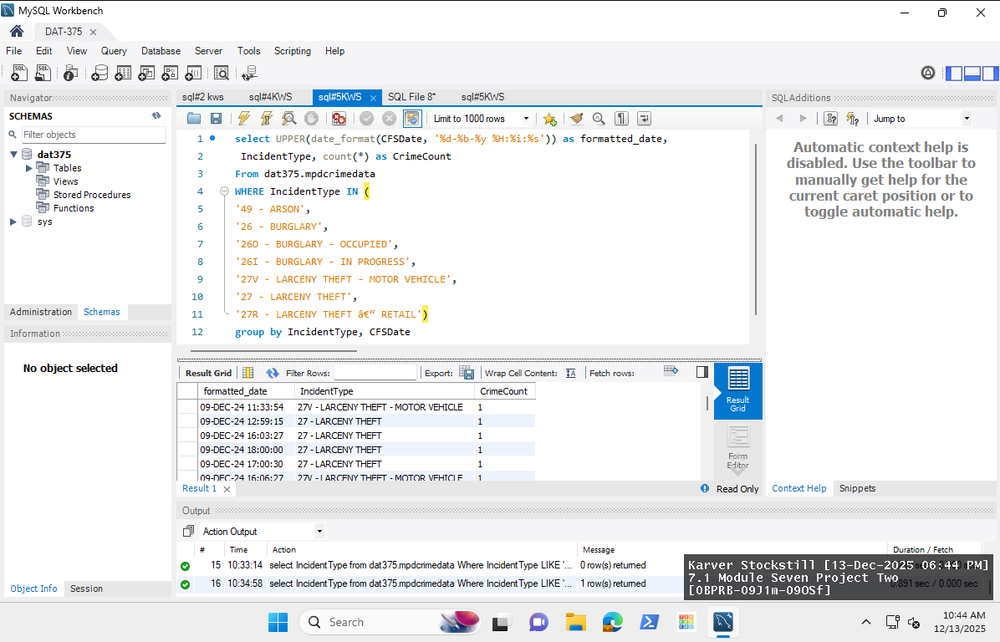
Script #6
merged_df = pd.merge(df, df2, on = ‘Date’, how = ‘inner)

3.2 Run the scripts to analyze the data and validate the output
Script #1
Was to filter the storm data to just include the storm event types with the beginning and ending date and times of Miami, Florida
Script #2 – Script #4
To filter the property crimes that included in the MPD dataset, I needed to extract the crimes only related to larceny, burglary and arson. Script #2 gave me the output of 49-ARSON, Script #3 gave me the output of 27v-LARCENY THEFT – MOTOR VEHICLE, 27-LARCENY THEFT, and 27R-LARCENY THEFT – RETAIL, and Script #4 gave me the output of 26-BURGLARY, 26O-BURGLARY – OCCUPIED, and 26I-BURGLARY – IN PROGRESS.
Script #5
Having all the property crimes relevant to the MPD data set I put them all together with the dates and times of the property crimes committed. I also formatted the date and times of the MPD dataset with UPPER(date_format() ‘%d-%b-%y %H:%i:%s’) to align with the layout of the storm dataset for better analysis. This date format is day – abbreviated month in uppercase - year hour:minuete:second.
Script#6
After loading the data sets from MySQL I created a query for the storm event data and called it df and created query2 for my crime data calling it df2. This scripts shows how I merged these to data frames together on the like dates in order to create visualizations. I performed an inner merge, which allowed me to bring together the data frames and only their matching values, exclusion of rows happens if there is no corresponding match with either data frame (Geeks, 2025). The inner merge used Dates as the matching value, this is because I want the dates of the storm events to align with the property crimes that where committed, this allows for the more accurate analysis.

IV. Drawing Conclusions

4.1 Present the results of the analysis to stakeholders
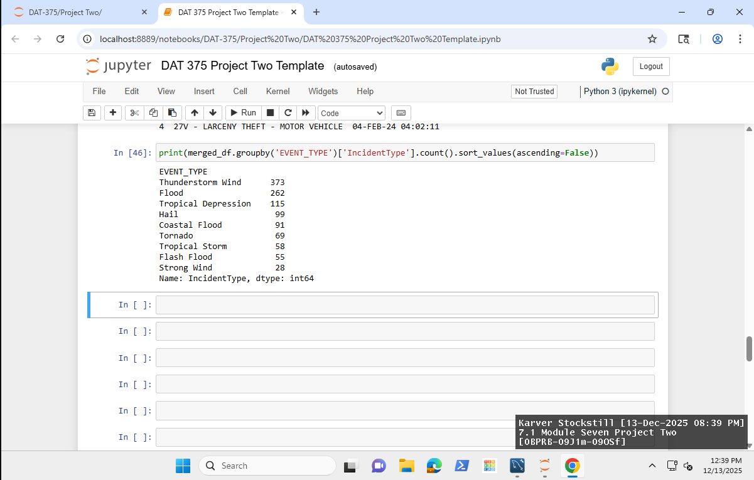

This shows the result of my inner merger and grouping the storm event type with the number of incidents that occurred. From this we can see that Thunderstorm Wind has the highest property crime of three-hundred and seventy-three. From this the MPD can see that the storms to give additional preparation time for should include Thunderstorm Wind, Flood, and Tropical Depression.
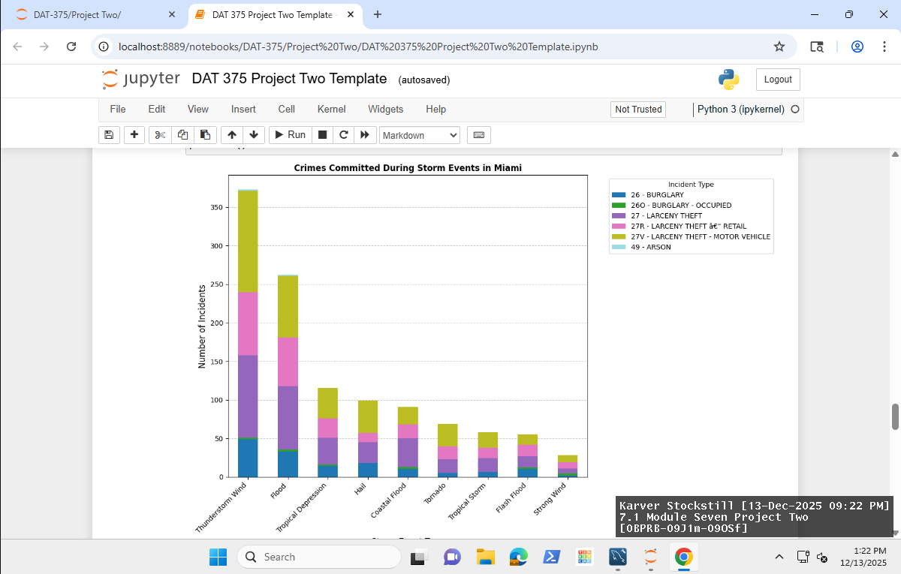

The visualization above presents a stacked bar graph illustrating property crimes associated with each storm event. This format effectively differentiates the frequency of various property crimes for each type of storm, providing clear insights into crime volume by category. Such analysis assists the MPD in identifying which storm events are correlated with increased property crime rates and offers guidance on specific crimes for which to allocate resources and prepare. The graph indicates that Larceny Theft of a Motor Vehicle was the most prevalent property crime during all storm events. Additionally, the highest incidence of property crime occurred during Thunderstorm Winds.

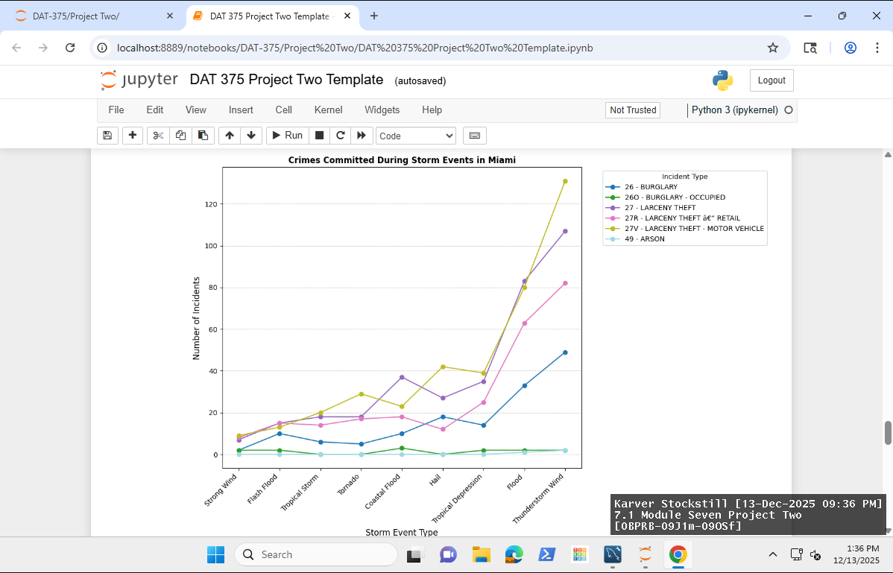
The visualization above presents multiple line graphs, each representing a distinct property crime and illustrating fluctuations corresponding to storm events shown on the x-axis. This enables the MPD to analyze how specific property crimes vary in relation to different storm events. Notably, the visualization indicates that larceny theft of motor vehicles is the most prevalent property crime, and that thunderstorm winds are associated with a higher incidence of property crimes compared to other storm events.
The accompanying pie charts provide a breakdown of the proportion of each property crime during various storm events. These charts serve as valuable resources for the MPD when anticipating particular storm events in the Miami area. By referencing the relevant pie chart, the MPD can strategically allocate resources and enhance awareness across the department.
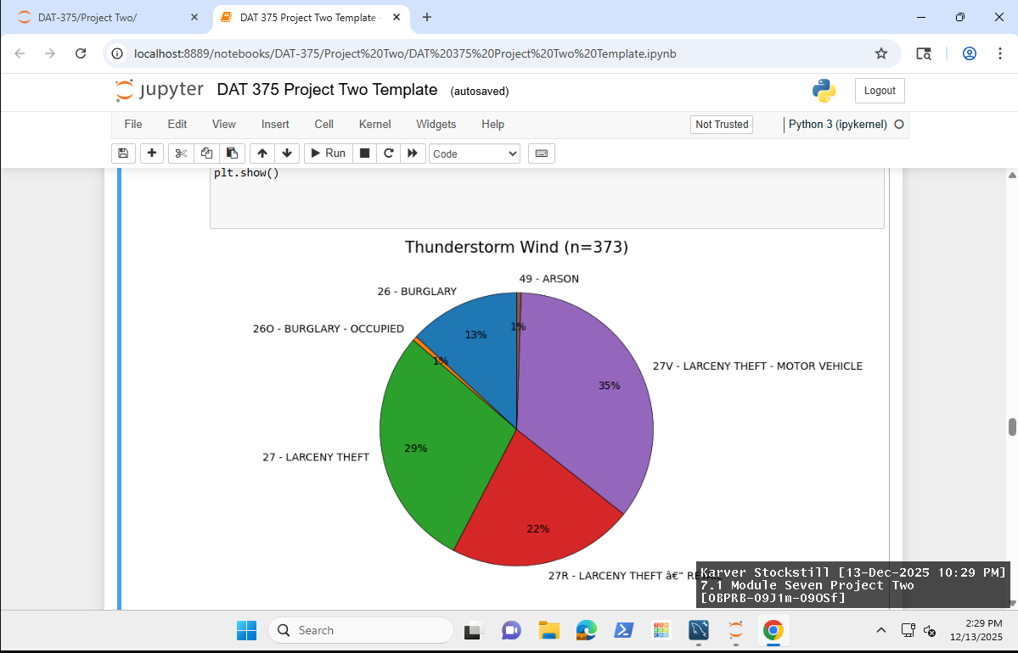
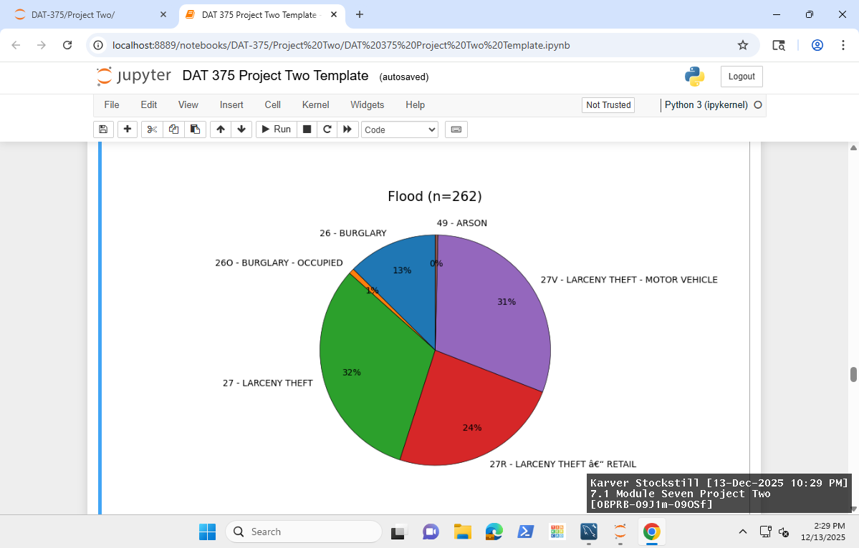
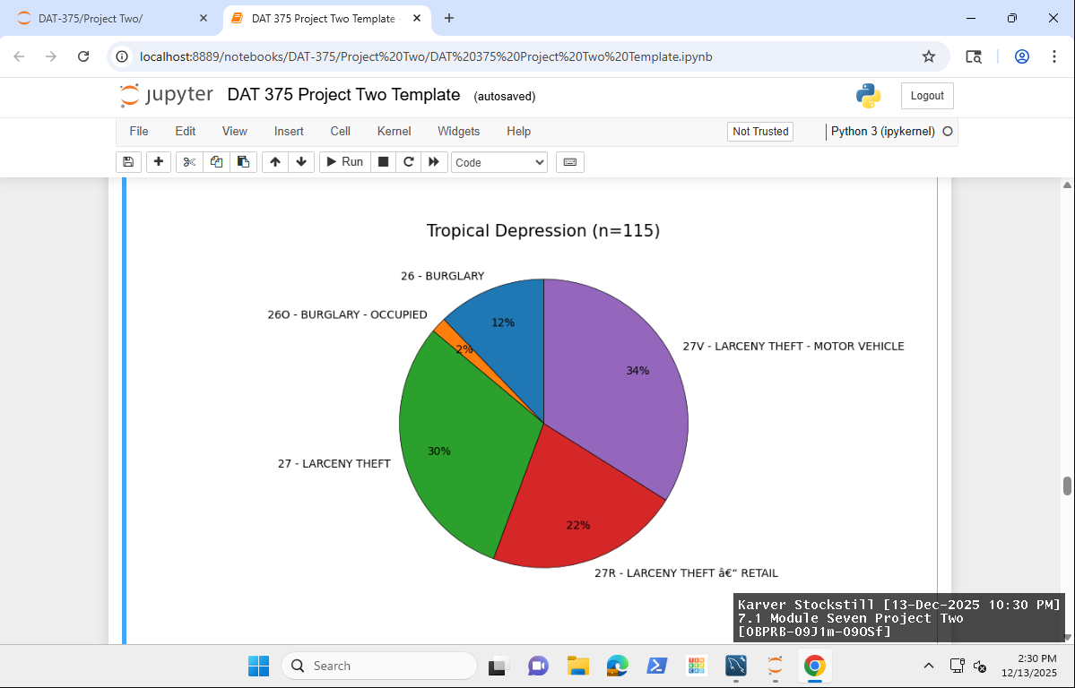
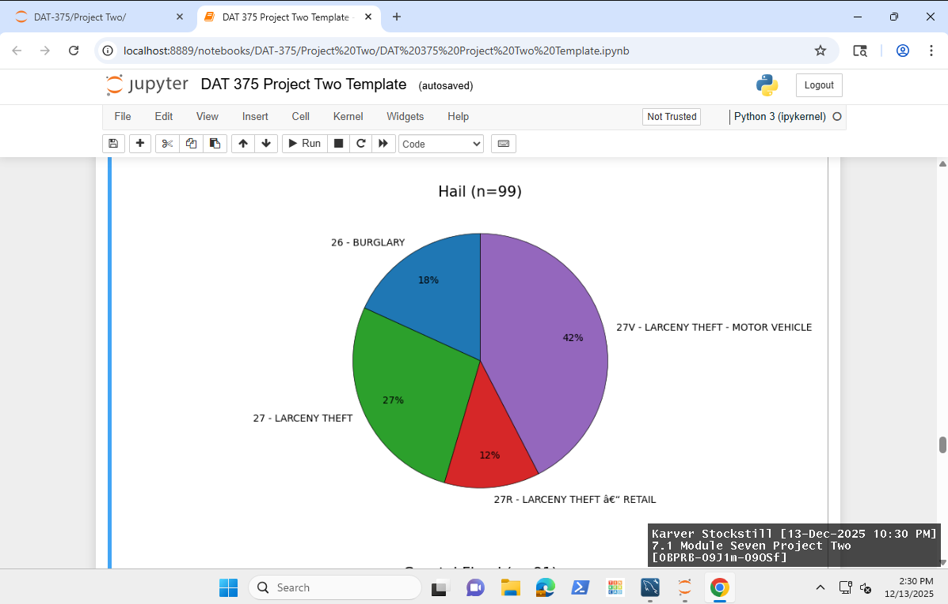
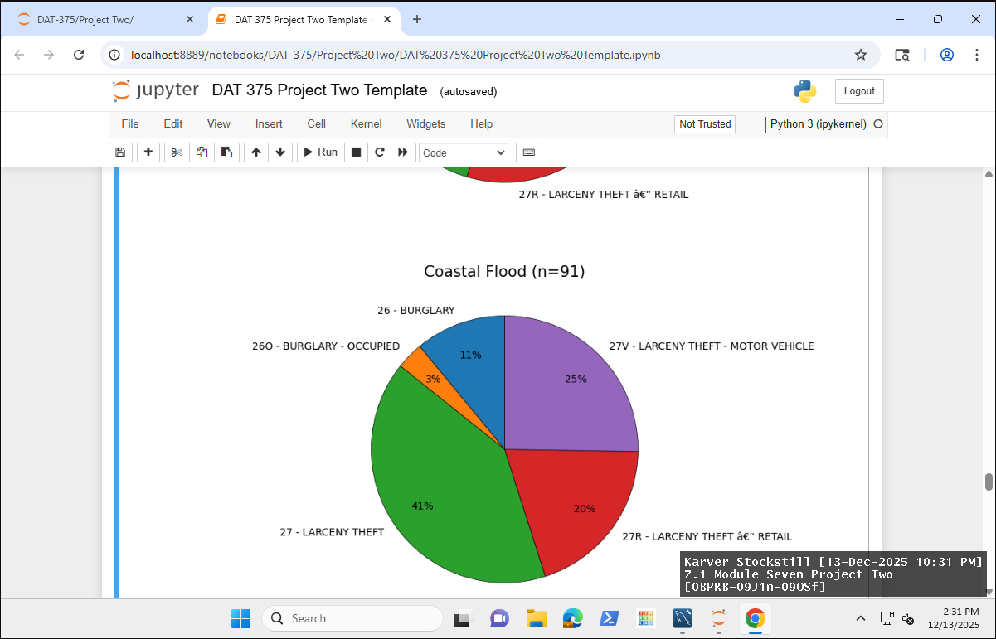
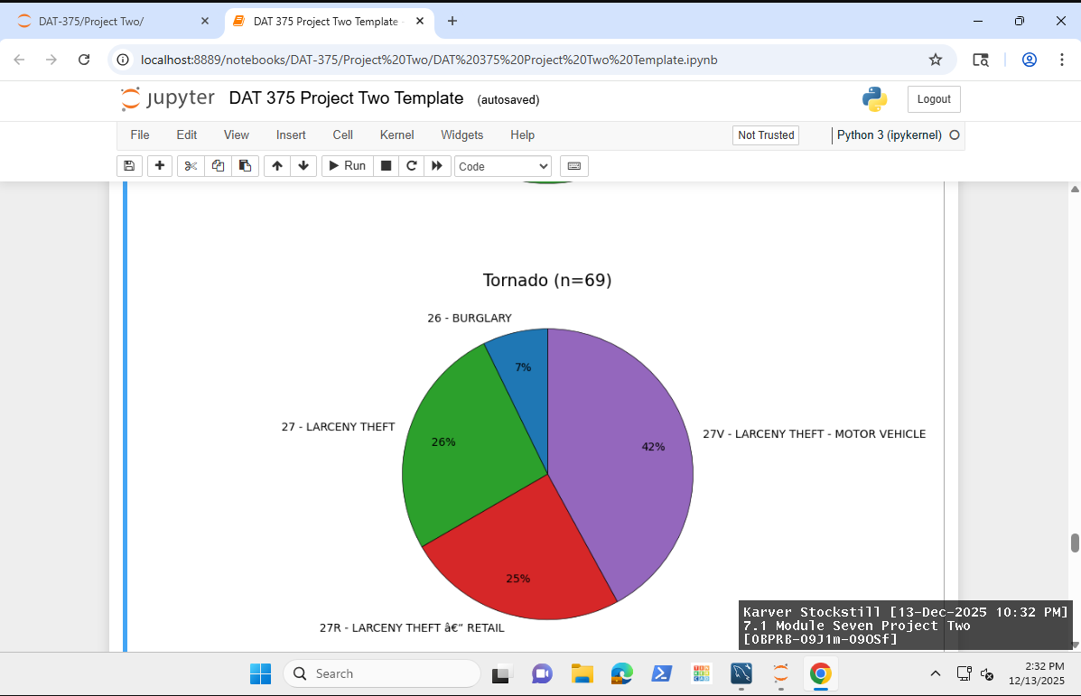
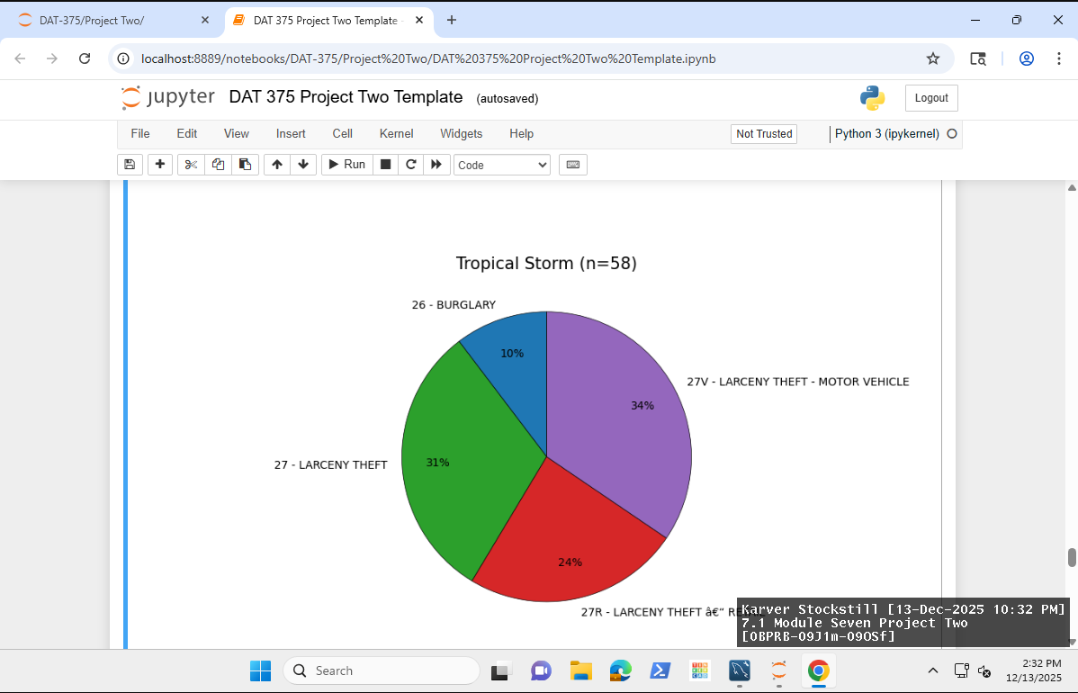
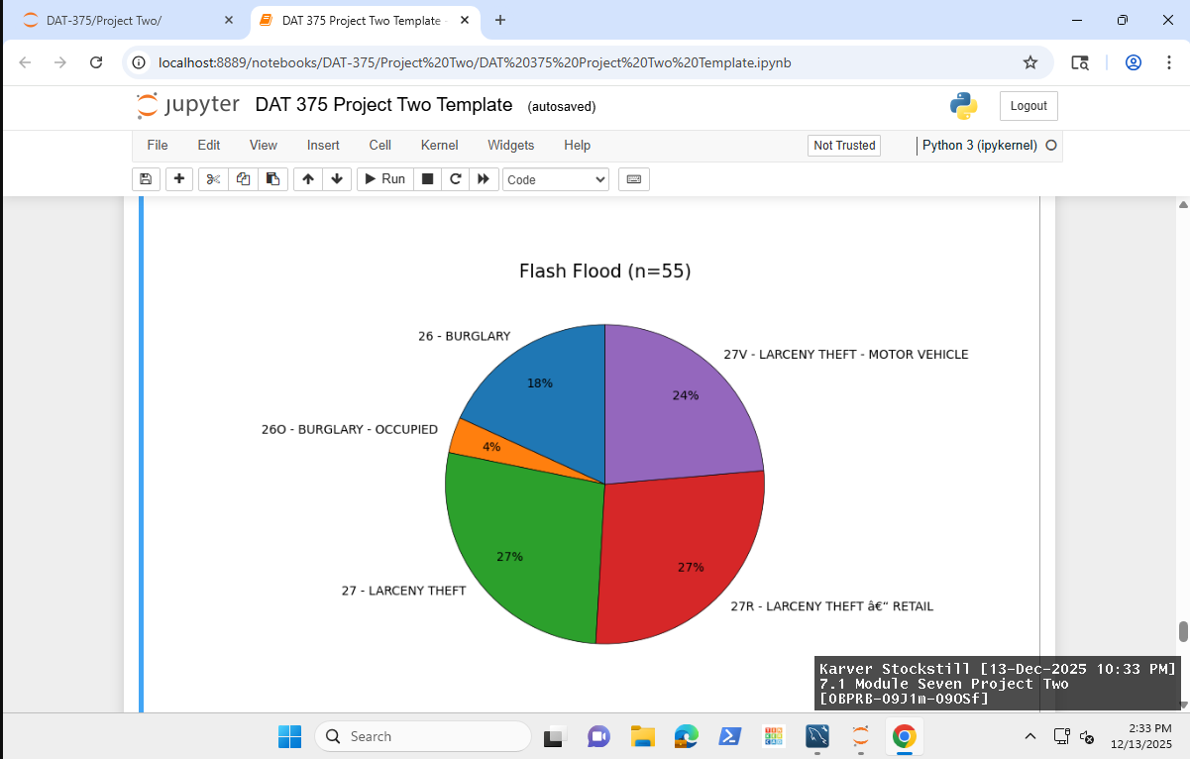
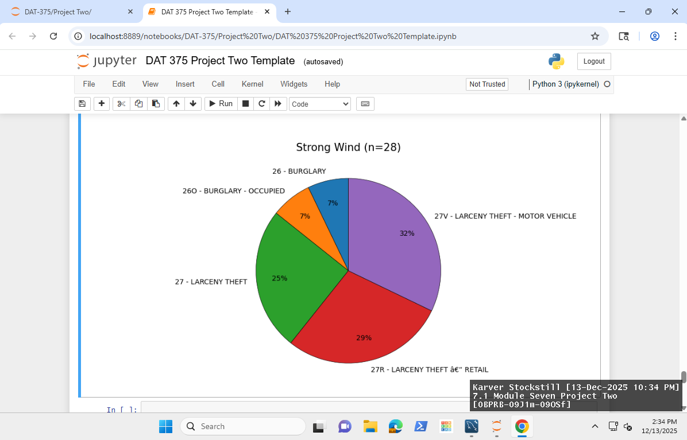

4.2 Determine whether the problem was addressed, including any challenges and limitations
This analysis effectively addressed the issue presented by the MPD by illustrating property crimes that occurred in conjunction with storm events in Miami. The accompanying visualizations support the findings and provide the MPD with relevant data to inform their preparation for property crime during future storm scenarios.
However, the analysis does present certain challenges and limitations. While it offers insights into property crimes associated with storm events, not all storms are of equal severity and timeframe. Therefore, although one might assume that overall crime patterns would persist regardless of a storm's intensity, this cannot be conclusively determined based on the current data.

4.3 Report potential new findings
This analysis indicates that the MPD possesses resources capable of assisting in the prediction of future property crimes associated with storm events. By leveraging these tools, the MPD can proactively prepare for impending storms by strategically allocating resources to specific areas requiring monitoring and increased vigilance. While it may not be possible to prevent all instances of property crime, the predictive insights provided by this report expect to significantly reduce crime rates during such events. Additionally, these findings can support requests for additional personnel for targeted storm responses and facilitate collaboration with other departments as severe weather approaches. Effective advance planning enables efficient allocation and preparation for overtime staffing needed during storm-related incidents.
Property crimes tend to increase during storm events, often due to diminished police response and patrols as resources redirect to address storm-related emergencies. Furthermore, evacuations may leave residences and vehicles more vulnerable to criminal activity. Opportunistic offenders may view storms as occasions to commit crimes with reduced risk of apprehension. This analysis offers valuable guidance for deterring criminal activity and enhancing residents' sense of security during adverse weather conditions.

References

FBI. (n.d). FBI: 2019 CRIME in the UNITED STATES. https://ucr.fbi.gov/crime-in-the-u.s/2019/crime-in-the-u.s.-2019/topic-pages/property-crime
Rao, Seth. (2024 December, 16). What Are the 6 Key Data Quality Metrics and How to Automate Them on Azure and Snowflake for Data Trustability. https://firsteigen.com/blog/6-key-data-quality-metrics-you-should-be-tracking/
GeeksforGeeks. (2025 July, 23). Pandas Merge Dataframe. https://www.geeksforgeeks.org/pandas/pandas-merge-dataframe/

